**UNIT 1: CELL STRUCTURE, CELL PHYSIOLOGY & HISTOLOGY.**

**1.1:** Figure below shows a root hair cell in a section of a root surrounded by a soil solution of water potential, **-**300kpa. It rains, diluting the molecules dissolved in the water of the soil solution by three times.

1. 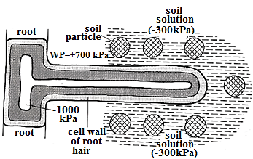Calculate the;
2. Change in the water potential of soil solution after raining.
3. water potential gradient between the soil solution and cell,

Before raining.

After raining.

1. Explain the difference in the effect of water potential gradients at the two conditions in a (ii) on the flow of water molecules between the root hair and soil.
2. Predict the effect of the change in water potential in a (i) on the pressure potential of root hair cell. Explain your answer.

**1.2:** In an investigation to determine the effect temperature on the membrane fluidity. Observations made are expressed graphically in **Figure 1**. In another investigation, two blood samples, **A** and **B**, were stored at 4 °C for 5 days. Sample **A** was then stored at 37 °C for 24 hours. Glucose was added to sample **B**, which was stored at 37 °C for 24 hours. The potassium ion concentration in the erythrocytes was recorded. The results are shown graphically in **Figure 2**.

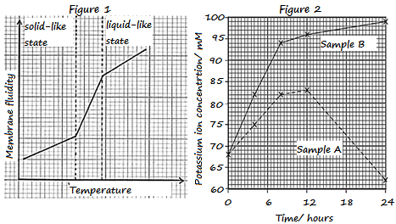**Using Figure 1:**

1. Describe the relationship between membrane fluidity and temperature.
2. (i) Explain the effect of temperature on membrane fluidity.

(ii) How does the liquid-like state affect the permeability of the membrane**?**

1. Account for the changes that would occur when 20% cholesterol is added to the plasma membrane**.**

**Using figure 2:**

1. Compare potassium ion concentration in erythrocytes from sample A and B.
2. Account for the differences above in (d).

f) How does the removal of potassium ions from medium surrounding the erythrocytes in sample B affect the osmotic balance**?**

**1.3:** (a) Describe the structure of plant cell wall

(b) Compare the structures of plant cell wall and plasma membrane

(c) Explain the functioning of Golgi apparatus in animal cells.

**UNIT 2: CHEMICALS OF LIFE, NUCLEIC ACIDS & PROTEIN SYNTHESIS.**

**2.1:** (a) Explain how pH affects enzyme-controlled reactions

(b) How does the spatial arrangement of enzyme proteins in membranes help regulate enzyme activity?

**2.2:** In an experiment to measure the rate of enzyme activity, two types of inhibitors were used to compare their effects on the rate of enzyme-controlled reactions.

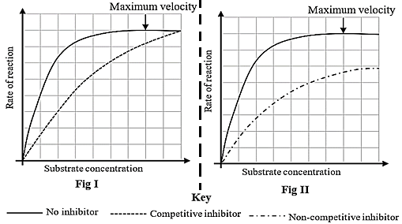(a) Explain the relationship between the rate of reaction and substrate concentration.

(b) Compare the rate of reaction in the presence of competitive and non-competitive inhibitors.

(c) Explain the difference in the rate of reaction in the presence of competitive and non-competitive inhibitors.

(d) Explain the significance of membrane-bound organelles on the activity of enzymes.

(e) State any six industrial applications and uses of enzymes.

**2.3:** (a) Describe how a whole set of codons required for formation of a polypeptide are assembled from DNA.

(b) How are codons assembled provide a basis for formation of a single polypeptide?

**UNIT 3: CELL DIVISION, GENETICS, & VARIATION & EVOLUTION.**

**3.1** a) Compare the processes of mitosis and meiosis in animals.

b) Explain the significance of mitosis and meiosis in sexual reproduction.

**3.2**

In the figure below, the **top graph** shows the changes in DNA cycle from interphase to mitosis of a cell in a body tissue. Below the graph are population histograms showing number of nuclei showing DNA content and DNA content of cells (diploid or tetraploid). The **first population histogram** shows number of nuclei showing DNA content and DNA content of cells in the differentiated tissue (non-dividing cells) during the different stages of mitosis. The **second population histogram** shows number of nuclei showing DNA content and DNA content of cells in the proliferating tissue (rapidly dividing cells) during the different stages of mitosis.

(a) From the figure; describe changes in the DNA cycle from interphase to the end of mitosis in;

(i) Differentiated tissue.

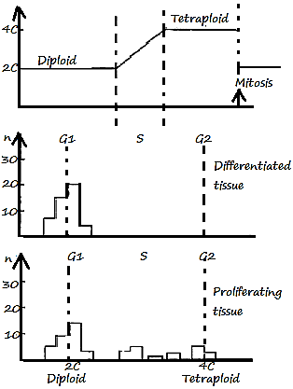(ii) Proliferating tissue.

(b) Account for the above changes in (a)

(i) Differentiated tissue.

(ii) Proliferating tissue.

(c) Compare the DNA content in proliferating and differentiated tissues.

(d) Explain the main events that occur during the

(i) G1 phase.

(ii) S phase.

(iii) G2 phase.

(e) The above phases are necessary prior to mitosis. Explain.

(f) Describe the process by which a polypeptide is formed from DNA.

**3.3**

**UNIT 4: ECOLOGY**

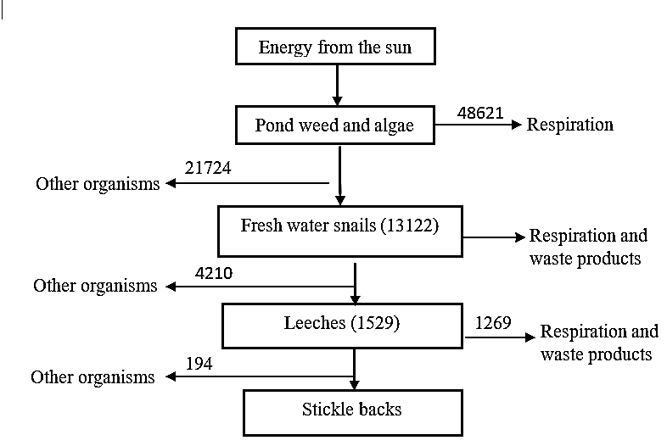**4.1**

a) What is meant by gross primary productivity?

b) The diagram below shows the energy flow in KJm-2year-1 through a freshwater ecosystem.

i) Calculate the gross primary productivity of the pond weed and algae

ii) How much energy is lost in respiration and waste products by the freshwater snails?

iii) Explain why carnivores would have a higher secondary productivity than herbivores.

**4.2**

**4.3**

**UNIT 5: NUTRITION, GASEOUS EXCHANGE, RESPIRATION, TRANSPORT & DEFENSE**

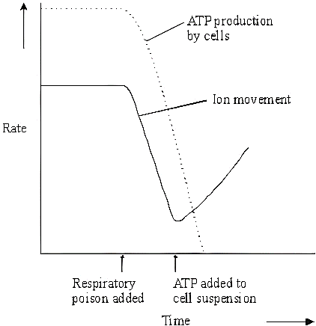5.1The graph shows the rate of ion movement and the rate of ATP production in an investigation carried out on a suspension of cells. At a certain point in the investigation, a respiratory poison was added to the cell suspension. Later, ATP was added to the same cell suspension.

a) Explain the changes in the rate of ion movement.

b) Suggest why there is no further decrease in the concentration of potassium ions in the solution with the inhibitor after 60 minutes.

c) The substance malonate has a structure very similar to the substrate of an enzyme that catalyses one of the reactions of respiration. Explain how malonate inhibits respiration.

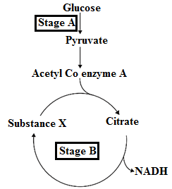**5.2** The diagram below shows two stages of respiration.

1. (i) Identify stages **A** and **B.**

(ii) State precisely in a cell where stages **A** and **B** takes place.

(iii) Name substance **X**.

1. Explain why one of the enzymes involved in the conversion of pyruvate to acetyl coenzyme A is called pyruvate dehydrogenase.
2. The conversion of citrate to substance **X** in stage **B** involves several reactions.
3. Name two molecules apart from NADH, which are produced during these reactions.
4. NADH is also produced during stage **A**. Explain the role of NADH when cells do not get sufficient oxygen for aerobic respiration.
5. Phosphofructokinase is an enzyme involved in stage **A**.

The presence of excess citrate inhibits this enzyme. Explain why this is important in the conservation of resources in the cell.

**5.3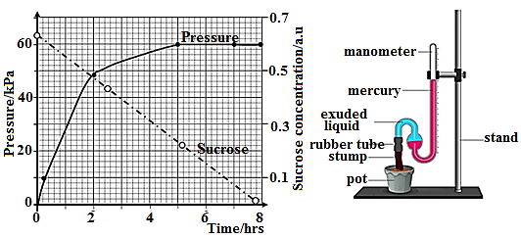 (a)** In an experiment to investigate the movement of water up the plant, the stem of a herbaceous plant was cut, the cut end of the stump continued to exude copious quantities of water, and a suitable mercury manometer was attached to the cut end, to measure the pressure. The experiment was left to stand for some time. The results were tabulated and then plotted in Figure I. At the same time, the amount of sucrose in the cells of the stem was monitored.

(i)  Describe the changes in pressure that took place during the period of the experiment.

(ii)  Explain the variation in the sucrose concentration.

(iii) Explain the effect of variations in sucrose on the pressure.

(iv) Apart from sucrose concentration, state and explain the other three factors that may affect the process being investigated.

(v) How is the process investigated cause the upward movement of water through the xylem vessels?

(vi) State any five adaptations of the xylem for the movement of water up the plant.

**5.4** 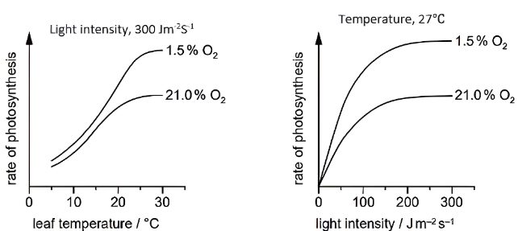Figure A and B show the effect of leaf temperature and light intensity on the rate of photosynthesis in a leaf of a temperate plant, *Atriplex patula* at two different oxygen concentrations. All measurements were made at atmospheric carbon dioxide concentration.

a) Describe the effect of the factors depicted in the figures, A and B on the rate of photosynthesis in *A. patula*

b) With reference to fig. A and B,

i) State the conditions under which oxygen exerts a significant inhibitory effect on photosynthesis in *A. patula*.

ii) Explain how oxygen inhibits photosynthesis in *A. patula*

c) Why was the experiment on the effect of leaf temperature (Fig A) carried out in conditions of light saturation?

**5.5**

**UNIT 6: HOMEOSTASIS, COORDINATION, BEHAVIOR, SUPPORT & LOCOMOTION**

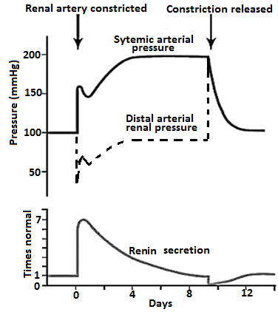**6.1:** Figure below shows effect of placing a **constricting clamp** on the renal artery of one kidney after the other kidney has been removed. Changes in systemic arterial blood pressure, renal artery distal to the clamp and rate of renin secretion are shown.

1. Describe the effect of renal artery constriction on,
2. Sytemic arterial pressure.
3. Distal arterial renal pressure.
4. Renin secretion.
5. Explain the observed changes in systemic arterial pressure, distal arterial renal pressure and renin secretion during renal artery constriction.
6. Explain the relationship between sytemic arterial pressure and distal arterial renal pressure when constriction is released.
7. Describe the production of acidic urine by the kidney of a runner after the race.
8. Account for the effect of drinking bicarbonate-rich mineral water on the pH of urine.

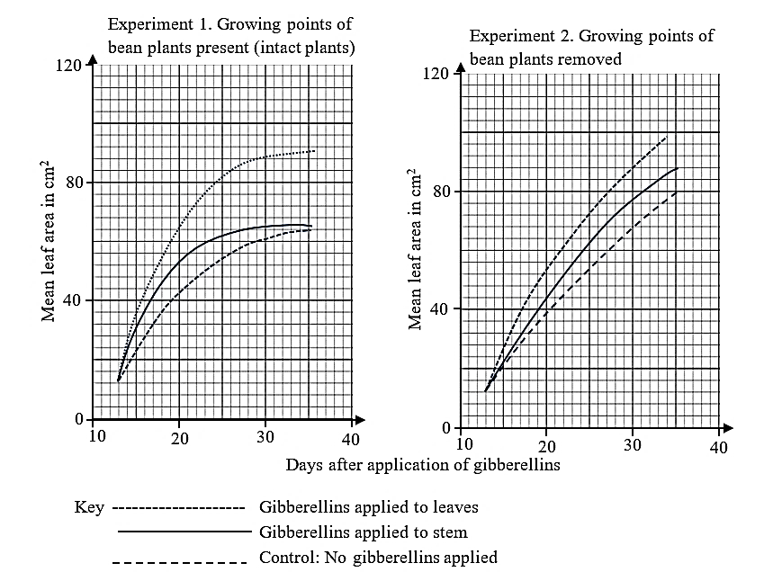**6.2:** An investigation was carried out into the effect of gibberellin on the growth of leaves in dwarf bean plants. Equal amounts of the hormone were applied either to the stem or the first leaves produced by the plants.

In one experiment the plants were left intact, but in a second experiment, the growing point (apex) of each plant was removed when gibberellin was applied. In both experiments, a control group of plants received no gibberellins.

Results are shown in the graphs below.

(a) Compare the effects of applying gibberellin on the stem and the leaves of the intact bean plants.

(b) (i) Describe the effect on leaf growth of removal of the growing points from the bean plants when no gibberellin is applied.

(ii) Suggest one reason why the removal of the growing point has this effect.

(c) How did the removal of the growing points from the bean plans affect the results of gibberellin applications?

(d) Explain how gibberellins exert their effects on plants.

**6.3** (a) The diagram below shows a representation of part of a myofibril in cross-section.

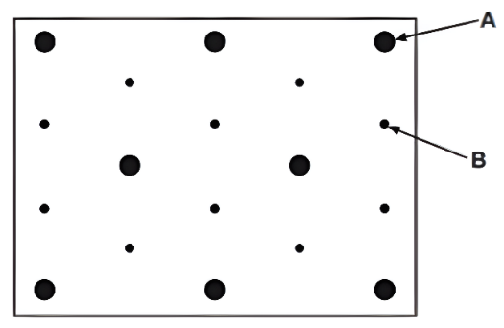 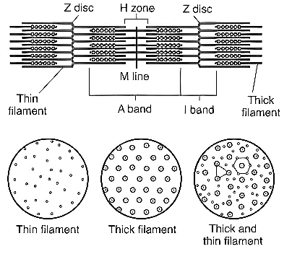

(i) Identify the type of protein found in the structures represented by A and B.

(ii) Draw a sarcomere to show the region (band) of the myofibril where the cross-section was taken.

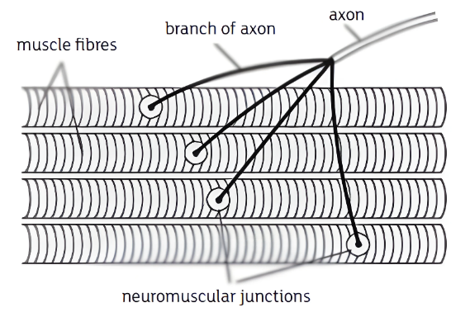(b) The diagram below neuromuscular junctions that bare specialised synapses that link neurones to muscle fibres.

(i) What is the main functional difference between neuromuscular junctions and neurone to neurone synapses in the nervous system?

(ii) Explain the significance of the axon of one motor neurone branching to a number of muscle fibres.

(c) Describe the sliding filament mechanism of muscle contraction.

**6.4** The diagram below shows the range in which body temperature is maintained by homeostasis.

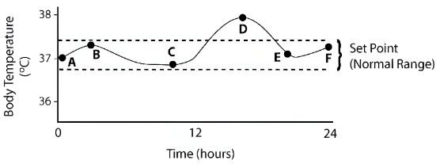a) Explain the type of homeostatic feedback system that is working between points

i) A and C on this graph.

ii) C and D on this graph.

b) Identify and explain the time interval when the body was exercising

**UNIT 7: REPRODUCTION, GROWTH & DEVELOPMENT**

**7.1**

**7.2**

**7.3**